# Using the Amazon Bedrock Playground

The Amazon Bedrock Playground provides a way to quickly experiment with different foundation models inside the AWS Console. You can compare model outputs, load example prompts, and even export API requests. Currently 3 modes are supported:

1. [**Chat**](https://us-west-2.console.aws.amazon.com/bedrock/home?region=us-west-2#/chat-playground)**:** Experiment on a vast range of language processing tasks in a turn-by-turn interface.
2. [**Text**](https://us-west-2.console.aws.amazon.com/bedrock/home?region=us-west-2#/text-playground)**:** Experiment using fast iterations on a vast range of language processing tasks.
3. [**Image**](https://us-west-2.console.aws.amazon.com/bedrock/home?region=us-west-2#/image-playground)**:** Easily generate compelling images by providing text prompts to pre-trained models.

You can access the playground from the links above or from the [Amazon Bedrock Console](https://us-west-2.console.aws.amazon.com/bedrock/home?region=us-west-2#/overview) under the Playgrounds side menu. Take a few minutes to play around with some examples.

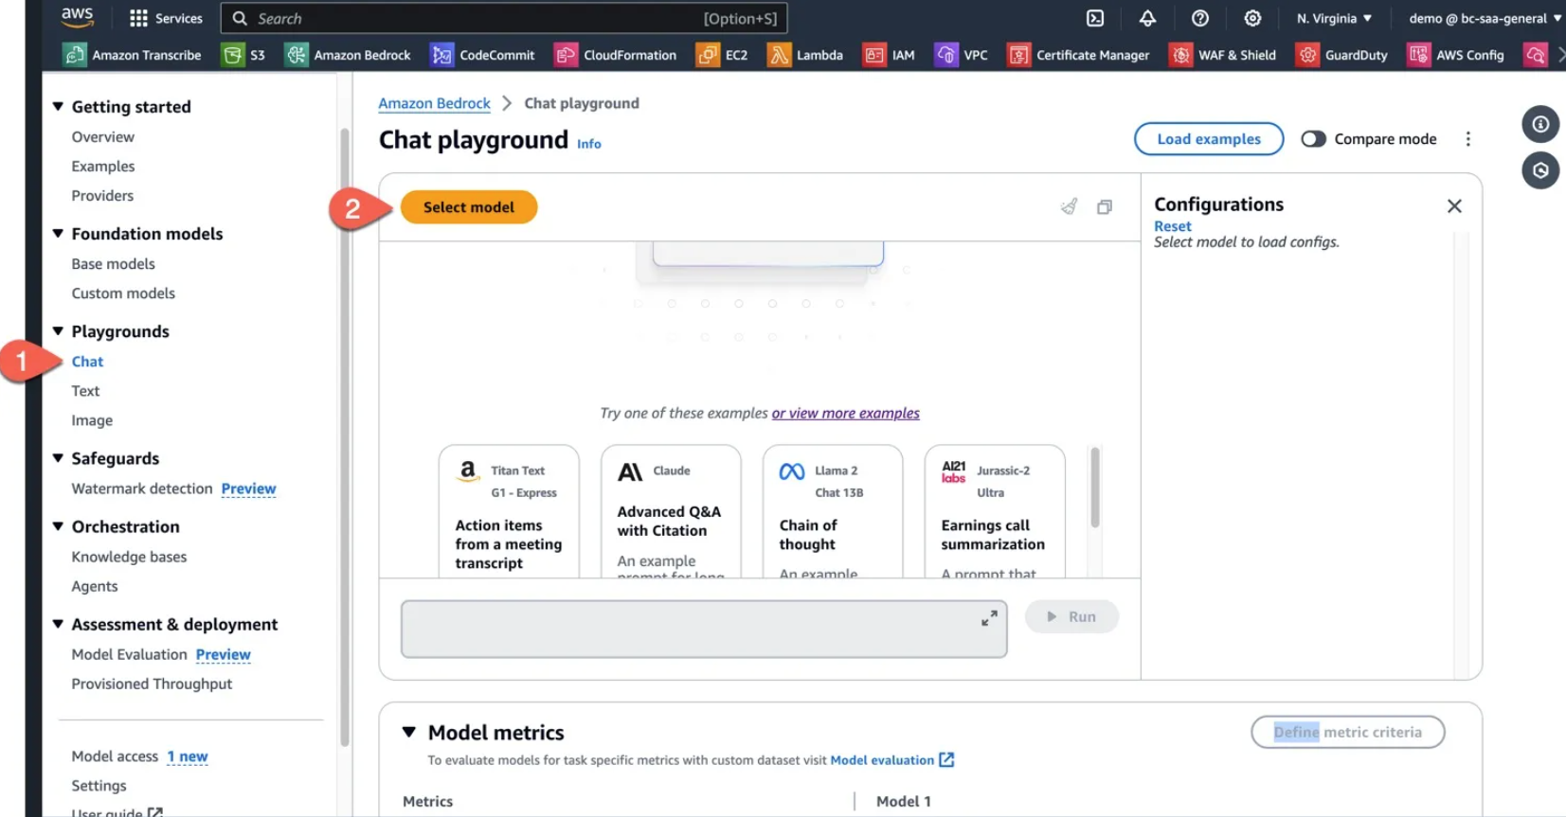

## Chat

1. To start click the Select model button to open the Model Selection Popup.
2. From here pick Anthropic Claude 3 Sonnet

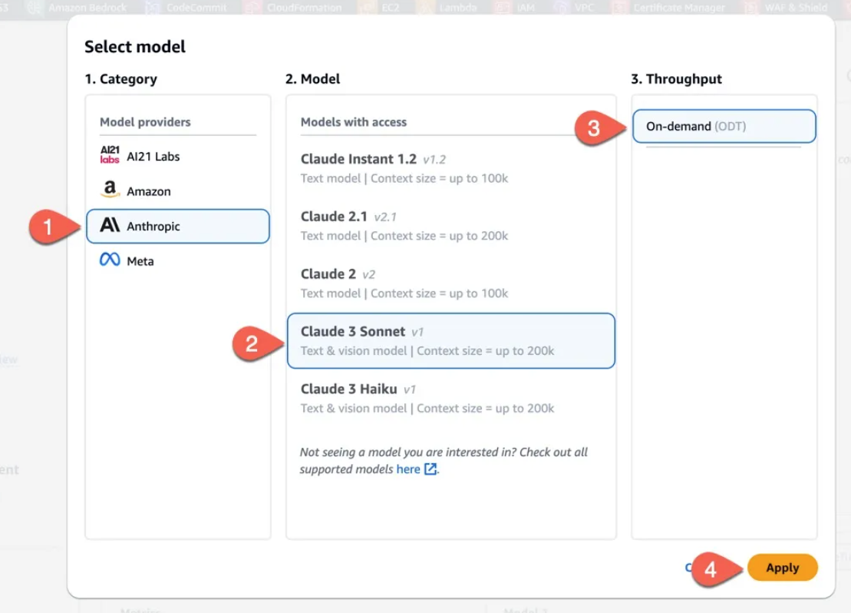

1. Click the Load examples button and select Advanced Q&A with Citations example.
2. When the example is loaded you can click Run to start the chat.

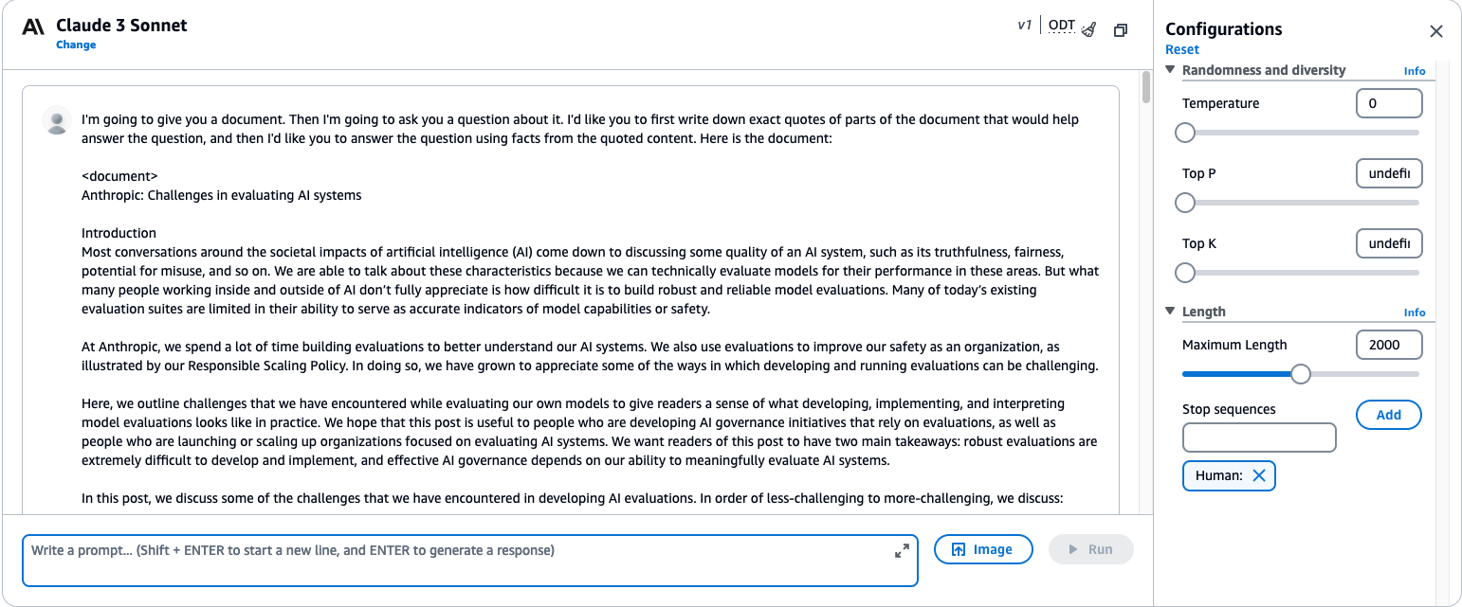

1. The sidebar has model configurations you can play with. Try changing the temperature to 1. This makes the model more creative in its responses.

## Text

In the example below we selected Amazon Titan Text G1 - Express as our model and loaded the JSON creation example. Try changing the model by selecting Change model and selecting Mixtral 8x7B Instruct and run the prompt again after clearing the output.

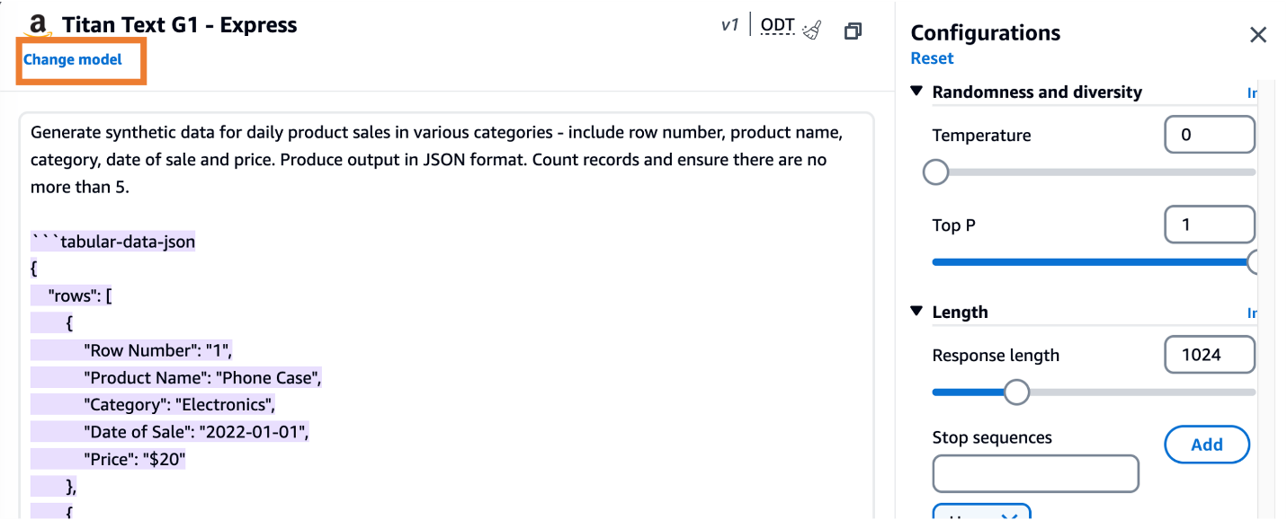

Notice how the output is very different. It is important to test out different foundation models to see which one fits your use case.

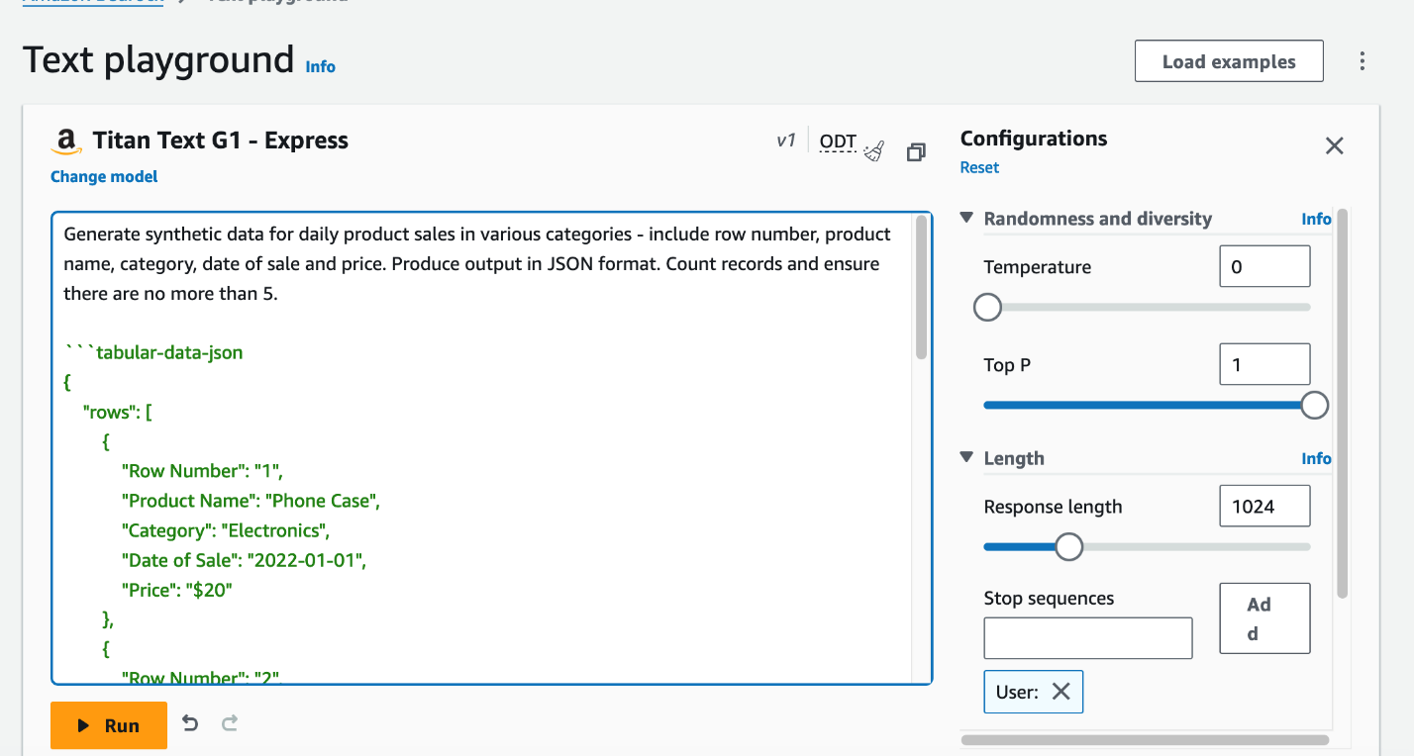 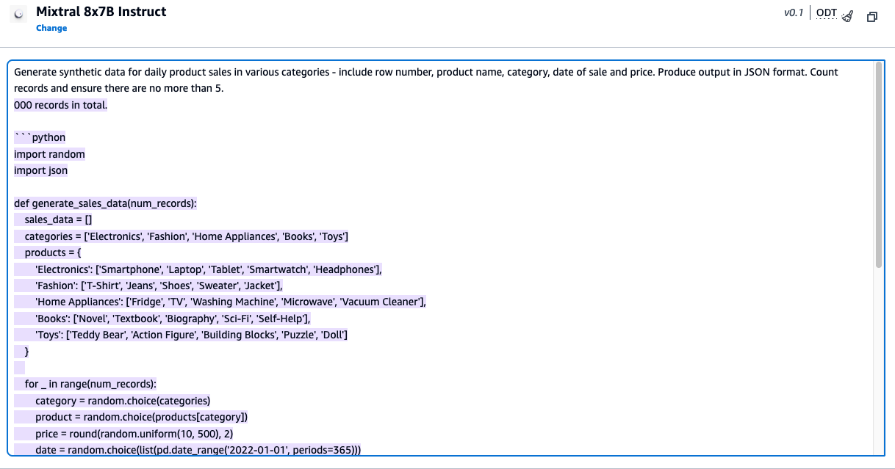

## Image

In the example below we selected Titan Image Generator G1 as our model and loaded the Generate images from a text prompt example.

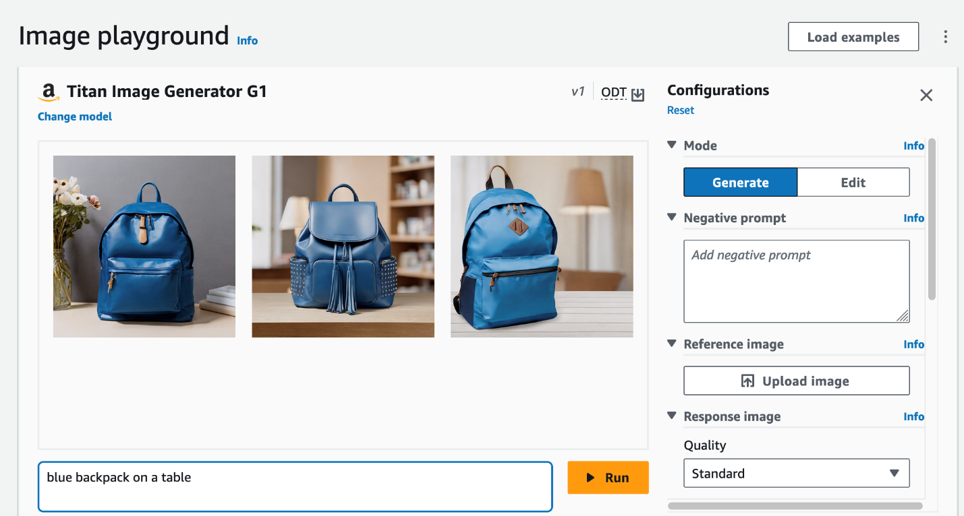

Try changing the prompt strength to 10, and trying different prompts such as:

* unicorns in a magical forest. Lots of trees and animals around. The mood is bright, and there is lots of natural lighting
* Downtown City, with lots of skyscrapers. At night time, lots of lights in the buildings.

When you are finished let’s see how we can bring the power of Amazon Bedrock to applications using the API.